SIMATS ENGINEERING (SAVEETHA SCHOOL OF ENGINEERING)
Department of Artificial Intelligence and Data Science
ASSESSMENT TOOL 3 – Mock Interview

Course Code: | DSA03 | Course Title: | Natural Language Processing
CO Assessed: | CO5 – Articulation | Assessment: | Assessment Tool 3 – Mock Interview
Weightage: | 30% of CIA
CO5 Statement: | Implement semantic models using predicate logic, word sense disambiguation and validate information retrieval techniques. (BL-5)
Student Name: | N.VENKATA SHIVA | Reg. No.: | 192472236
Section / Batch: | 2024 | Date: | 28-08-26
Code of Conduct
I N.VENKATA SHIVA(192472236) (Name / Reg No) certify that this submission is my original work and that I have adhered to the guidelines specified for this assessment. I understand that any violation of academic integrity rules will result in disciplinary action.
Signature of the Student: N.Venkat
Instructions
- Start the mock interview by entering the provided ChatGPT prompt exactly as given in the Annexure A in the next page. Enter your Name and Register Number when requested.
- Answer all 10 interview questions independently and in your own words using mobile chatgpt voice. Do not copy content from external sources or use AI-generated responses during the interview.
- Provide detailed and meaningful answers with appropriate technical terminology, examples, and justifications wherever applicable. One-line answers may lead to lower scores.
- Complete the interview in a single session. Ensure that all 10 questions are answered before requesting the final evaluation and assessment report.
- Submit the final ChatGPT-generated report printout, including the interview questions, your responses, question-wise rubric evaluation, and the Student Average Final Mark, as proof of completion.
- Duration: 30 minutes.

Section / Topic | Focus | Question No.
Discourse & Reference Resolution | Understanding discourse, anaphora resolution, reference tracking, and contextual interpretation in text | Q1
Text Coherence & Discourse Structure | Analyzing coherence relations, discourse organization, and maintaining meaningful text flow | Q2
Dialog Acts & Interpretation | Identifying dialog acts, speaker intentions, and conversational meaning | Q3
Dialog and Conversational Agents | Architecture, components, and working of conversational agents/chatbots | Q4
Language Generation Architecture | Stages of Natural Language Generation (NLG), pipeline architecture, and applications | Q5
Surface Realization & Discourse Planning | Transforming semantic representations into grammatically correct sentences and planning discourse | Q6
Machine Translation – Transfer Approach | Translation process using transfer-based methods and practical applications | Q7
Machine Translation – Interlingua Approach | Language-independent representation and multilingual translation framework | Q8
Statistical Approaches in NLP | Statistical language models, probability-based language generation, and machine translation | Q9
Integrated Case Study (Analytical & Problem Solving) | Real-world scenario involving discourse analysis, conversational agents, language generation, and machine translation | Q10

Annexure A – Mock Interview

CHATGPT PROMPT: copy and paste in your chatgpt
MOCK INTERVIEW ASSESSMENT – NLP (Language Generation and Discourse Analysis) Act as an expert Technical Interview Panel for Computer Science and Engineering students. Interview Domain:
Language Generation and Discourse Analysis Topics:
- Discourse
- Reference Resolution
- Text Coherence
- Discourse Structure
- Coherence
- Dialog and Conversational Agents
- Dialog Acts
- Interpretation
- Language Generation
- Architecture
- Surface Realization
- Discourse Planning
- Machine Translation
- Transfer Metaphor
- Interlingua
- Statistical Approaches Interview Instructions:
Step 1:
Ask the student to enter:
Student Name:
Register Number:

Step 2:
Conduct a technical interview consisting of exactly 10 questions. Rules:
- Ask only one question at a time.
- Wait for the student's response.
- Ask conceptual, analytical, application-based, and problem-solving questions.
- Include at least:
  - 2 questions on Discourse and Coherence
  - 2 questions on Conversational Agents and Dialog Acts
  - 2 questions on Language Generation
  - 2 questions on Machine Translation
  - 2 analytical or scenario-based questions

Step 3:
Store every question and answer.

Step 4:
After Question 10, evaluate the student using the following rubric. RUBRIC
Technical Knowledge (25)
Level 4:
Demonstrates strong and accurate subject knowledge with in-depth understanding

Level 3:
Shows good knowledge with minor gaps

Level 2:
Basic knowledge with noticeable errors

Level 1:
Lacks fundamental technical knowledge

Problem Solving (25)
Level 4:
Solves problems logically and applies concepts effectively in real scenarios

Level 3:
Applies concepts with moderate accuracy

Level 2:
Limited problem-solving ability; requires guidance

Level 1:
Unable to solve or apply concepts

Analytical Thinking (20)
Level 4:
Analyzes questions critically and provides well-structured logical answers

Level 3:
Provides reasonable analysis with some structure

Level 2:
Superficial or partially structured responses

Level 1:
No analytical thinking demonstrated

Communication (15)
Level 4:
Communicates clearly, confidently and professionally using appropriate terminology

Level 3:
Communicates well with minor hesitation

Level 2:
Communication lacks clarity or confidence

Level 1:
Unable to communicate effectively

Confidence (15)
Level 4:
Displays high confidence, positive attitude and professional behavior throughout

Level 3:
Shows good confidence with minor issues

Level 2:
Low confidence and inconsistent behavior

Level 1:
Lacks confidence and professionalism MARK CALCULATION
Level 4 = 100% of weightage
Level 3 = 75% of weightage
Level 2 = 50% of weightage
Level 1 = 25% of weightage

Technical Knowledge = 25 marks Problem Solving = 25 marks Analytical Thinking = 20 marks Communication = 15 marks Confidence = 15 marks

Calculate:
Final Score = Sum of all rubric scores

Step 5:
Generate the final report in the exact format below.

MOCK INTERVIEW ASSESSMENT REPORT

Student Name:A. Mohith krishna Register Number:192425199

INTERVIEW QUESTIONS AND RESPONSES

Q1: What is discourse in NLP? How is it different from a single sentence? Question Asked:
Student Response:
Discourse means a group of connected sentences that gives a complete meaning. A single sentence gives one idea, but discourse connects many sentences together. Q2:What is reference resolution? Why is it important in NLP?
Question Asked:
Student Response:

Reference resolution means finding what a word like he, she, it, or they refers to.
It is important because it helps the NLP system understand the correct meaning of a sentence. Q3:What is discourse structure?
Question Asked:
Student Response:

Discourse structure shows how different sentences or parts of a text are connected.

Q4: What is coherence?
Question Asked:
Student Response:Coherence means the sentences in a text are logically connected.

Q5:What is a conversational agent? Give two examples. Question Asked:
Student Response:A conversational agent is a system that communicates with people using natural language.

Q6:What is a dialogue act? List any four types. Question Asked:
Student Response:A dialogue act shows the purpose of a person's statement in a conversation.

Q7:What is Natural Language Generation (NLG)? Question Asked:
Student Response:NLG is the process of generating human-readable sentences using data or information.

Q8:What is Machine Translation? What is its primary objective? Question Asked:
Student Response:Machine Translation means translating text from one language to another using a computer.

Q9:What is the transfer approach in Machine Translation? Question Asked:
Student Response:The transfer approach converts the structure of the source language into a structure suitable for the target language.

Q10:What is a statistical approach in NLP? Question Asked:
Student Response:A statistical approach uses probability and training data to process natural language.

RUBRIC EVALUATION

Criterion | Weightage | Assigned Level | Marks Awarded
Technical Knowledge | 25 | Level X | XX
Problem Solving | 25 | Level X | XX
Analytical Thinking | 20 | Level X | XX
Communication | 15 | Level X | XX
Confidence | 15 | Level X | XX

SUMMARY TABLE

Technical  Knowledge (25) | Problem Solving (25) | Analytical Thinking (20) | Communication (15) | Confidence (15) | SubQ Total | Student Avg Final Mark
Level X | Level X | Level X | Level X | Level X | XX.X | XX.X

OVERALL FEEDBACK

Strengths:

- List strengths Areas for Improvement:
- List improvements Interview Readiness:
- Excellent / Good / Average / Needs Improvement End the report after the Interview Readiness section.
After evaluating each answer, do NOT display the marks immediately. Store the evaluation internally.
After Question 10 is completed:

- Generate a Question-wise Evaluation Table for all 10 questions.

- For each question assign:

  - Technical Knowledge Level

  - Problem Solving Level

  - Analytical Thinking Level

  - Communication Level

  - Confidence Level

  - SubQ Total

- Calculate SubQ Total using: Level 4 = 100% weightage
Level 3 = 75% weightage

Level 2 = 50% weightage

Level 1 = 25% weightage

- Calculate Student Avg Final Mark as:

Average of all 10 SubQ Totals

- Display:

  - Complete interview questions

  - Student answers

  - Question-wise evaluation table

  - Student Avg Final Mark

  - Overall strengths

  - Areas for improvement

  - Interview readiness

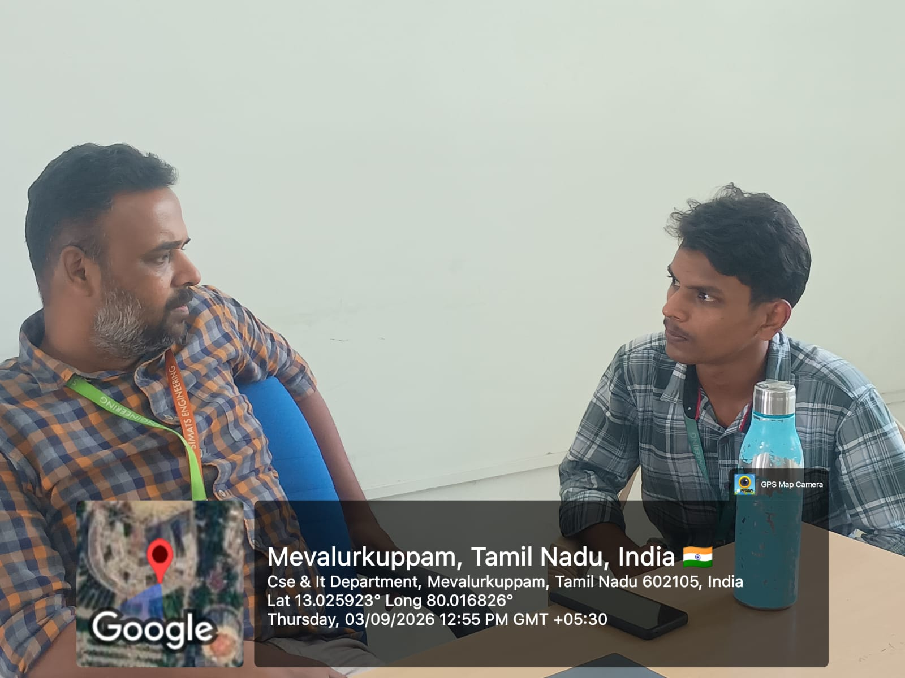

Rubrics for Calculation

Criteria | Weigh tage | Level 4 (Exemplary) | Level 3 (Proficient) | Level 2 (Developing) | Level 1 (Beginning)
Technical Knowledge | 25 | Demonstrates strong and accurate subject knowledge with  in-depth understanding | Shows good knowledge with minor gaps | Basic knowledge with noticeable errors | Lacks fundamental technical knowledge
Problem Solving | 25 | Solves problems logically and applies concepts effectively in  real scenarios | Applies concepts with moderate accuracy | Limited problem-solving ability; requires  guidance | Unable to solve or apply concepts
Analytical Thinking | 20 | Analyzes questions critically and provides well-structured, logical answers | Provides reasonable analysis with some structure | Superficial or partially structured responses | No analytical thinking demonstrated
Communic ation | 15 | Communicates clearly, confidently, and professionally with  proper terminology | Communicates well with minor hesitation | Communication lacks clarity or confidence | Unable to communicate effectively
Confidence | 15 | Displays high confidence, positive attitude, and professional behavior throughout | Shows good confidence with minor issues | Low confidence; inconsistent behavior | Lacks confidence and professionalism

Q. No. / Criteria Level | Problem Understanding | Algorithm Design | Use of Control Structures | Pseudoco de Structure | Complet eness | Sub. Total | Total  %
1 | 3 | 3 | 4 | 3 | 3 |  | 80
2 | 3 | 3 | 4 | 3 | 3
3 | 3 | 3 | 3 | 3 | 4
4 | 3 | 3 | 3 | 3 | 4
5 | 3 | 3 | 3 | 3 | 4
6 | 3 | 3 | 3 | 3 | 4
7 | 3 | 3 | 3 | 3 | 4
8 | 3 | 3 | 3 | 3 | 4
9 | 3 | 3 | 3 | 3 | 4
10 | 3 | 3 | 3 | 3 | 4

Faculty In-charge | Course Coordinator | Program Director
Signature: | Signature: | Signature:
Date: | Date: | Date:

